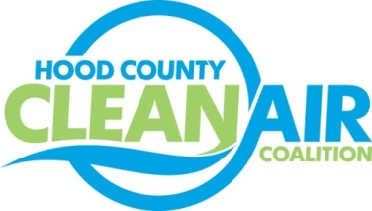
Meeting: Tuesday, August 5, 2014
American Town Hall
220 N. Travis Street, Granbury, Texas 76048
8:30-9:30 a.m.

Agenda

- Call Meeting to Order
- EPA Updates – Carrie Paige
  - Review of the Current Ozone Standard
  - Status of the Implementation Rule for the Current Ozone Standard
- Energy Efficiency – Randy Harding of Luminant
- Regional Updates – Michelle McKenzie
- Air Quality Technical Meeting: August 12, 2014, 10:00 AM
- Natural Gas Vehicle Procurement: Navigating through the State Contract: August 21, 2014, 10:00 AM
- TCEQ TERP Workshop: Drayage Trucks; Thursday, September 4, 2014 – more details/exact times to be determined later (will include a Spanish session)
- Air Quality Funding Opportunities
- Local Updates - Michelle McKenzie
  - Air North Texas Conference Call Report
  - Ozone Season Update
  - Rider 8
    - Status
    - Air Quality Planning Conference
    - Expense Approval Process
    - Propane Infrastructure Meeting Follow Up
- Discussion
- Adjourn

