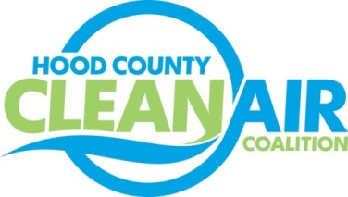
Meeting: Tuesday, April 7, 2015
American Town Hall
220 N. Travis Street, Granbury, Texas 76048
8:30-9:30 a.m.

Agenda

- Call Meeting to Order
- EPA Updates – Carrie Paige, EPA
- Regional Updates – Michelle McKenzie
  - EPA’s Implementation Rule for 2008 8-hour ozone standard finalized April 6th.
  - April is National Car Care Month
  - Air North Texas Reminder: Clean Air Action Day – June 26
  - Air Quality Funding Opportunities for Vehicles
- Local Updates – Michelle McKenzie
  - Review of March Meeting Summary
  - Comments for EPA Proposal to Revise the 2008 Ozone Standard
  - Amendments to Charter for Coalition Activities
  - Participation in Judging of Earth Day Museum at Emma Roberson Elementary School
  - Reports
    - Air North Texas Conference Call
    - DFW Clean Cities Meeting
    - Ozone Update
  - Rider 8 Review of Projects
    - Monthly Budget Review for January
    - Status of Projects
      - Technical Reports
      - PSA on Radio
      - Participation in Events
      - Decals/ Anti-idling signs
      - Surrey Bicycles
      - Propane Fueling Task
      - Lawnmower Exchange
g.) Proposed Tasks for FY 16/17
5.) Discussion
- Adjourn

