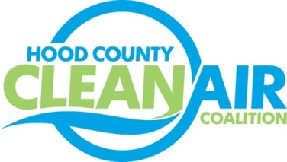
Meeting: Tuesday, June 2, 2015
Neely House
304 East Rucker Street, Granbury, Texas 76048
8:30-10:00 a.m.

Agenda

- Call Meeting to Order
- EPA Updates – Carrie Paige
- Regional Updates – Michelle McKenzie
  - Funding Opportunities at www.nctcog.org/aqfunding
    - TERP Light Duty Motor Vehicle Purchase and Lease Incentive Program
    - EPA Grant Funding
  - Air North Texas Reminder: Clean Air Action Day – June 26
- Local Updates – Michelle McKenzie
  - Review of May Meeting Summary
  - Review of Projects
    - Monthly Budget Review for April
    - Status of Projects
      - Radio PSAs
      - Anti-idling signs
      - Bike Equipment
      - Propane Refueling Stations
      - Lawn Equipment Exchange
      - FY 16/17 PGA
  - Rider 8 Contract Extension
  - Certificate of Formation
  - Ozone Advance 2015 Update
  - Reports
    - Ozone Advance/ Nonattainment Areas Conference Call
    - Air North Texas Meeting
    - Ozone Update
    - Earth Day Museum Prizes
5.) Discussion
6.) Adjourn

