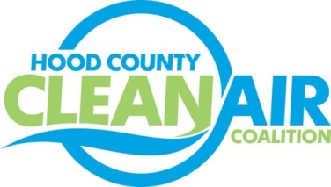
Meeting: Tuesday, March 3, 2015
American Town Hall
220 N. Travis Street, Granbury, Texas 76048
8:30-9:30 a.m.

Agenda

- Call Meeting to Order
- EPA Updates – Carrie Paige, EPA
- Regional Updates – Chris Klaus, NCTCOG
  - EPA Proposal to Reclassify the DFW Area from Serious to Severe Nonattainment
  - RTC Comments on the Dallas-Fort Worth State Implementation Plan Revision
  - NCTCOG Comments to EPA Regarding Proposed Rule for Ozone; Executive Board Item 15
  - Texas Transportation Commission’s Minute Order Authorizing Speed Limit Changes
  - Air Quality Funding Opportunities for Vehicles
  - Property Assessed Clean Energy Meeting for City Managers: March 6, NCTCOG Offices
  - Clean Cities Annual Report – due date March 12 (for fleets)
  - DFWCC Meeting – Propane Subcommittee: March 31, NCTCOG Offices
- Local Updates – Michelle McKenzie
  - Review of February Meeting Summary
  - Comment for EPA
  - Decals to Support Partnering Entities
  - Coalition Incorporation
    - Status
    - Amendment to Charter to Remove Lake Granbury Area EDC as Coordinator for Coalition Activities
  - Reports
    - Regional Ozone Advance Conference Call
    - EPA Webinar on Transport
  - Rider 8 Review of Projects
    - Monthly Budget Review for January
    - Status of Projects
iii.) Proposed Tasks for FY 16/17
5.) Discussion
- Adjourn

